Step 1: Enter the values in the .env file. Run the below commands in the separate Terminal.
npm run mcp:jira:remote # http://localhost:4001/mcp
npm run mcp:postman:remote # http://localhost:4002/mcp
Run npm Install and npm run dev.
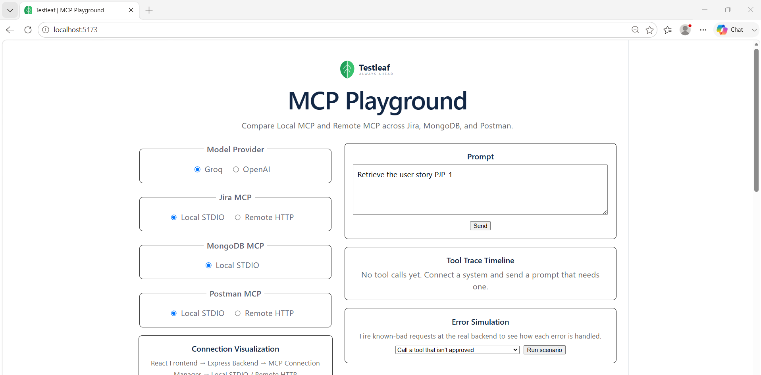
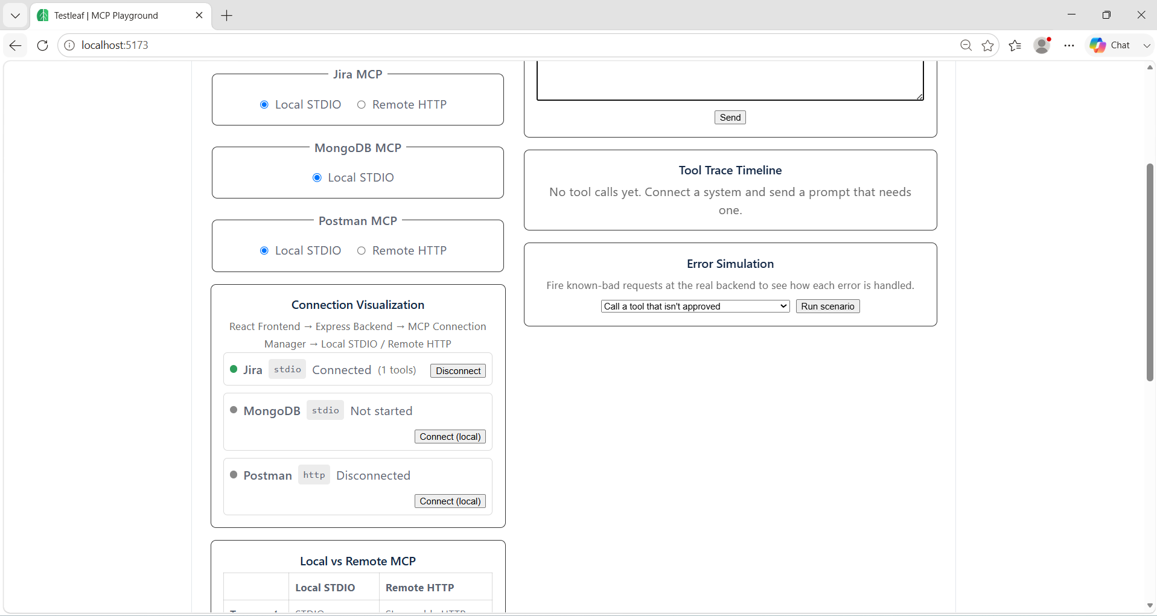
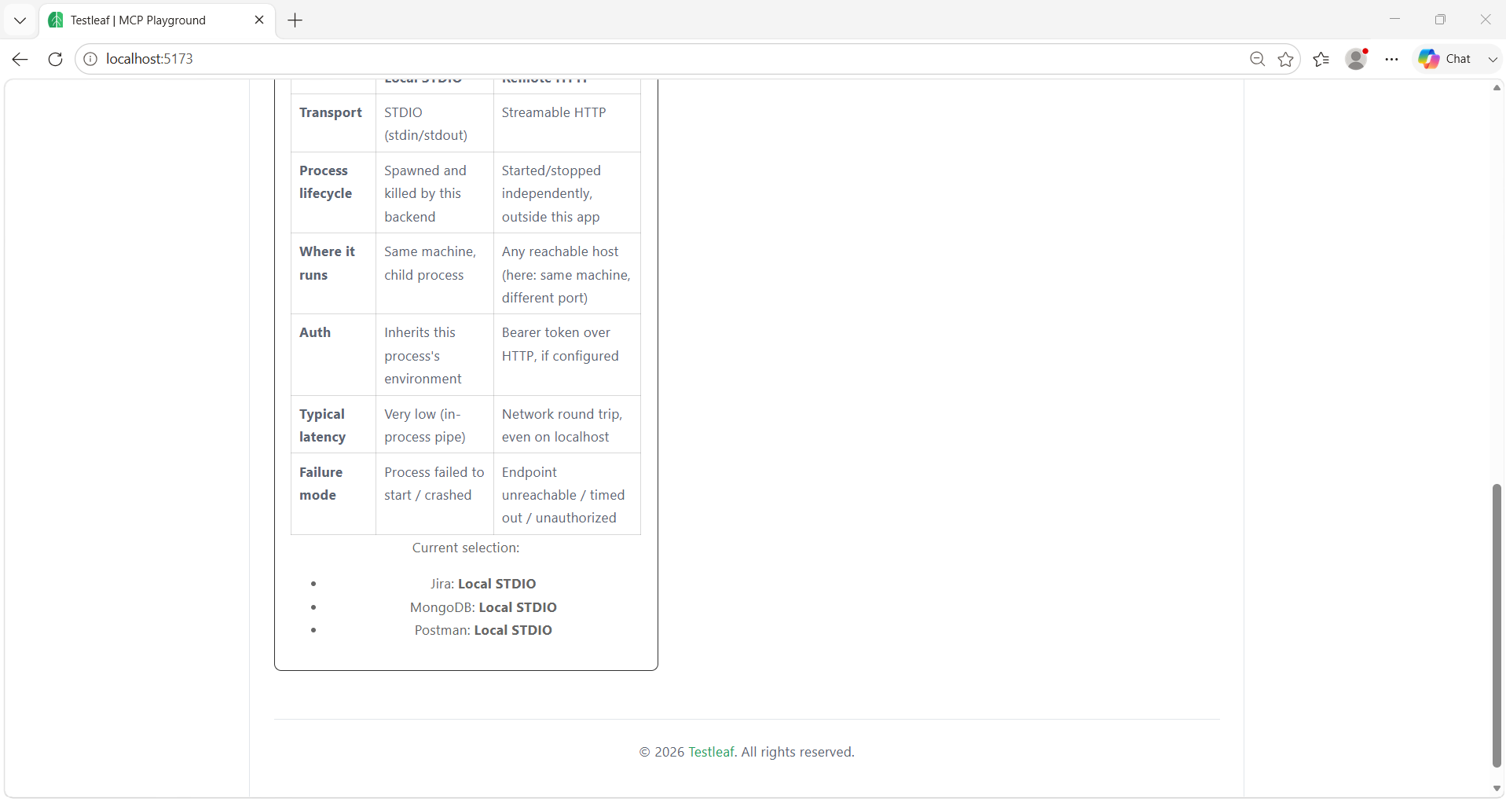
Local JIRA:
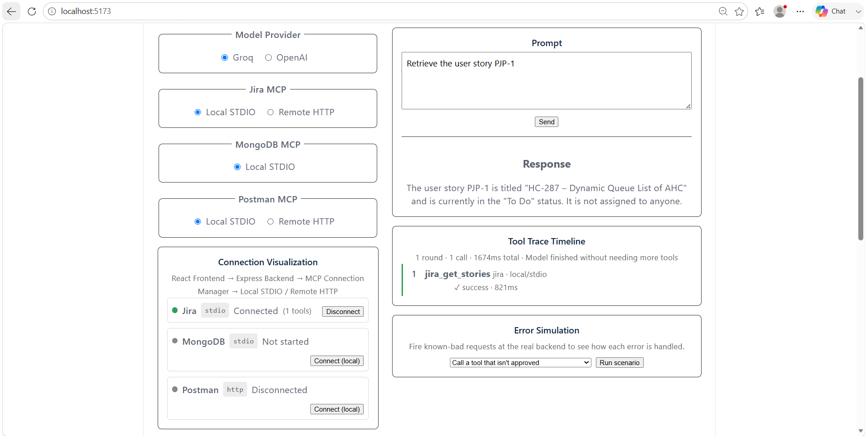
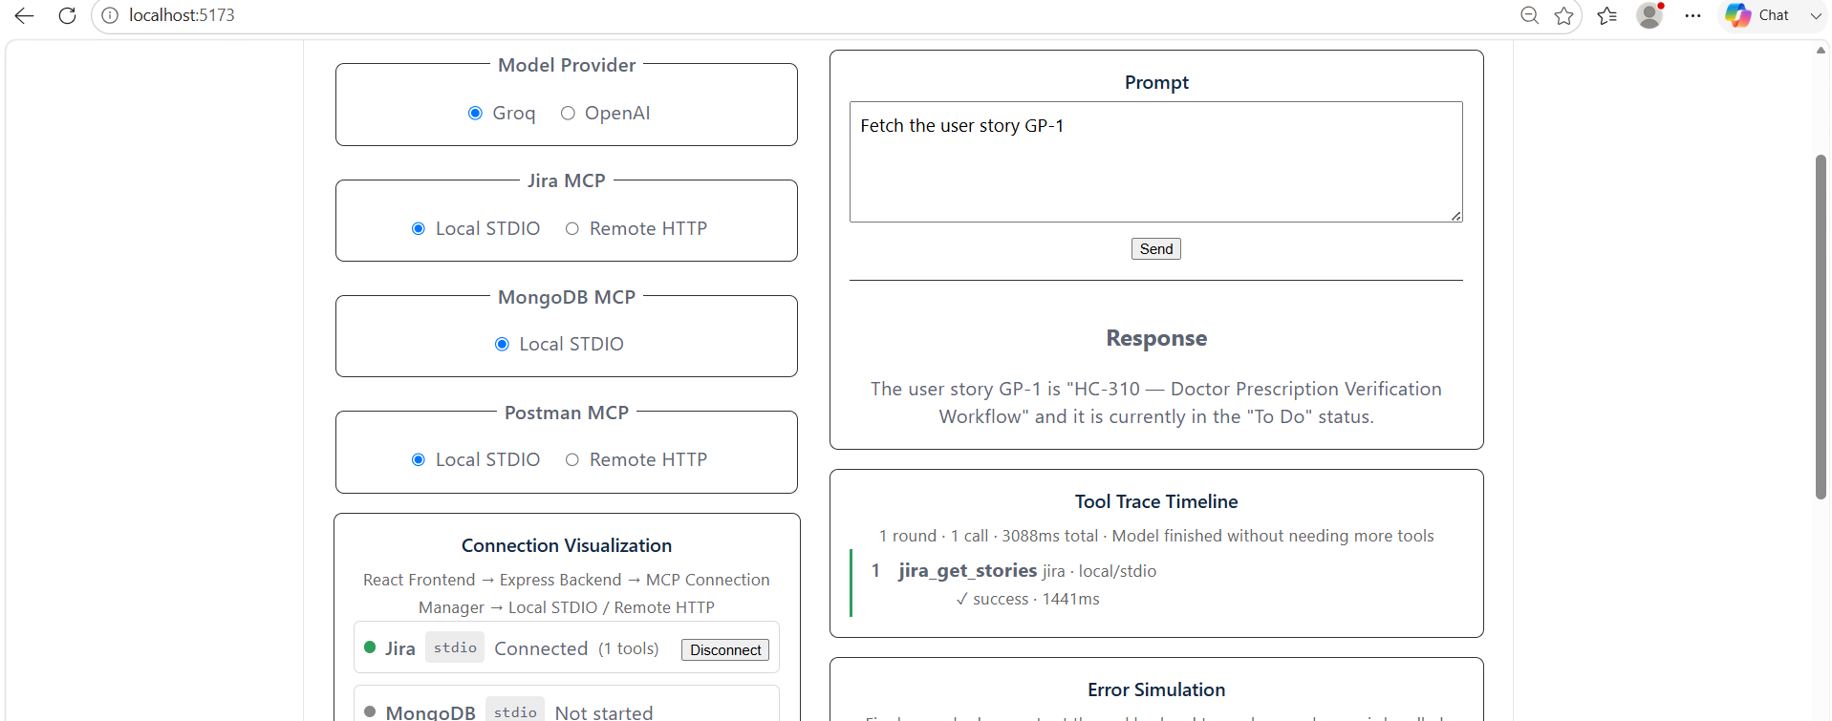
Local MongoDB:
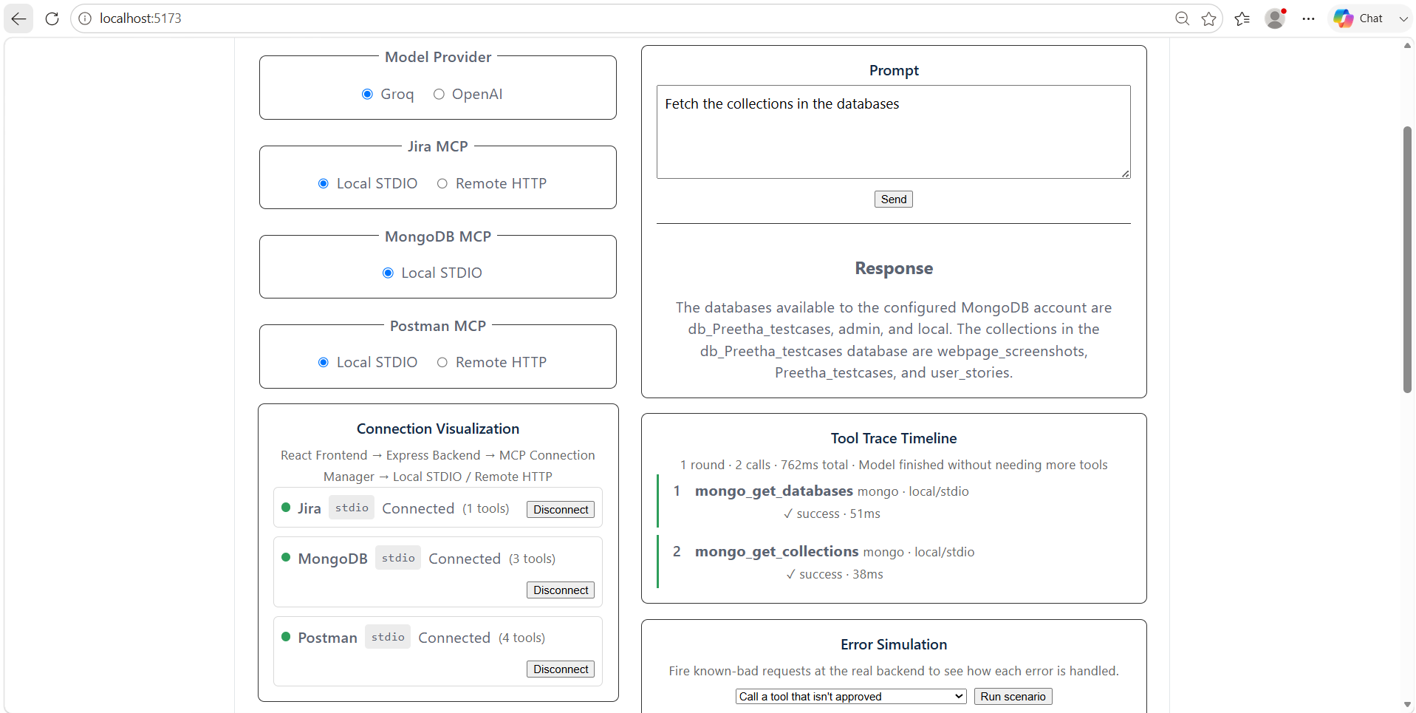
Local Postman:
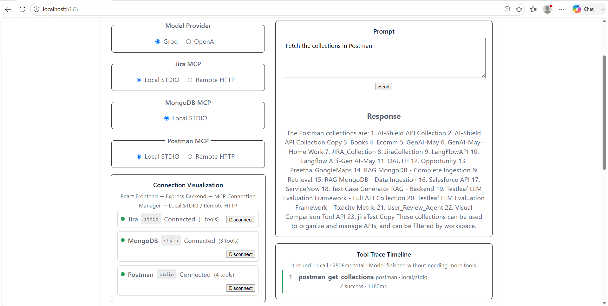
Remote JIRA:
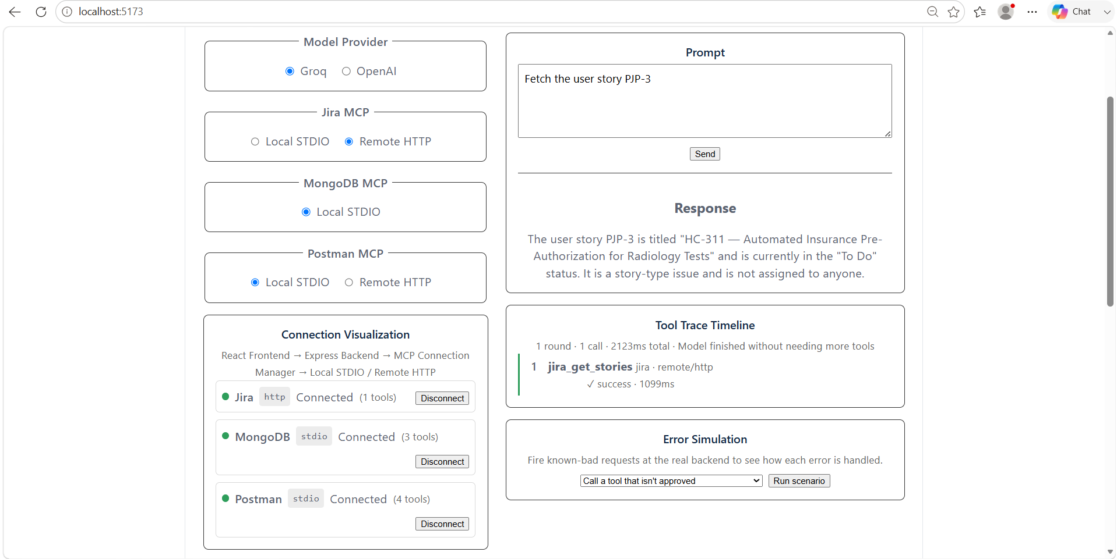

Remote Postman:
